CSA1509-Cloud computing and Big Data Analytics
Name : DHARSHANA SIVAKUMAR
Reg.no: 192511054

EXP 16. Create a Cloning of a VM and Test it by loading the Previous
Version/Cloned VM
Aim:
To Create a Cloning of a VM and Test it by loading the Previous
Version/Cloned VM.
Steps:
- Download VMware software and install it as Type-2 Hypervisor.
- Download Ubuntu or tiny os as ISO image file.
- In VMware workstation Create new VM
- Do the configuration based on given conditions.
- Create VM
- Go to VM ManageClone.
- Launch the VM.
Implementation:
- Download and open VMware software.
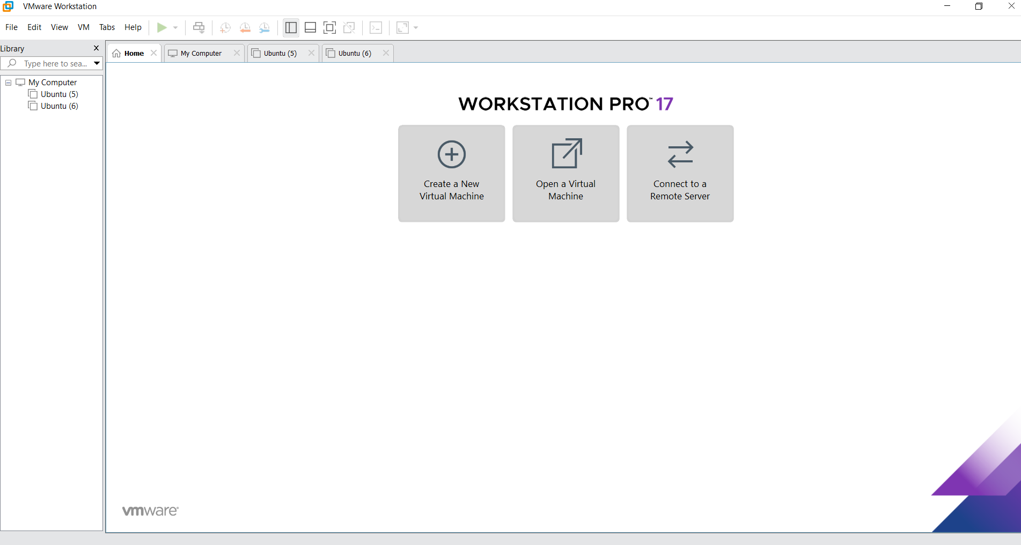
2.Create a new VM

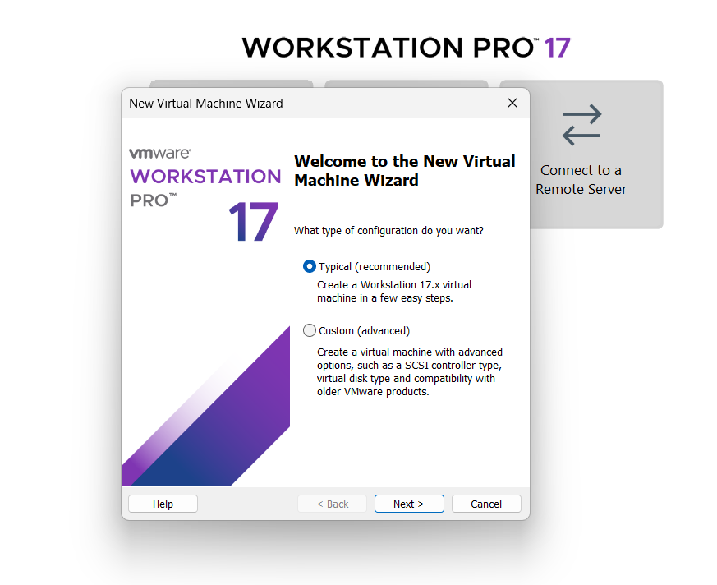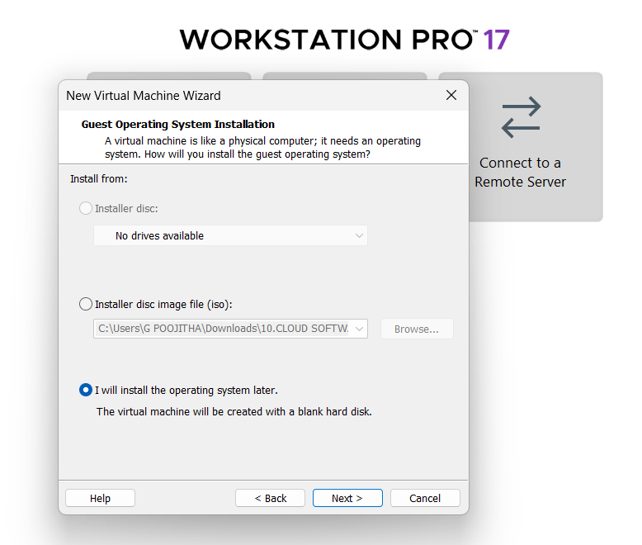
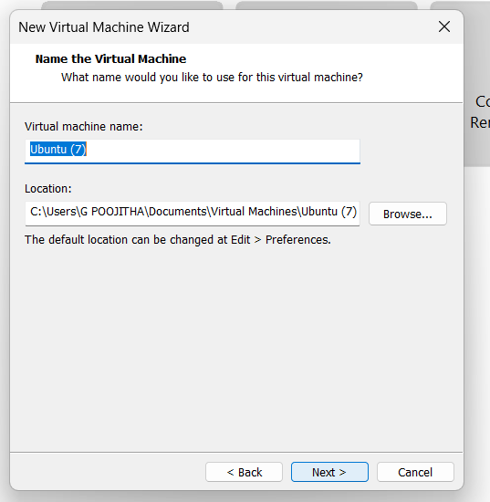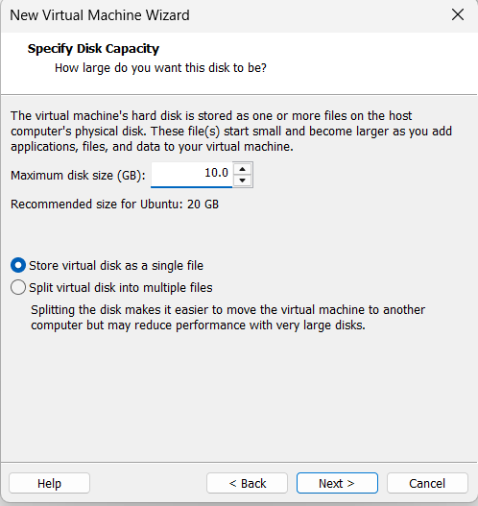
Name it anythingclick on nextAdjust the size of disk change the option to first and then click on next.
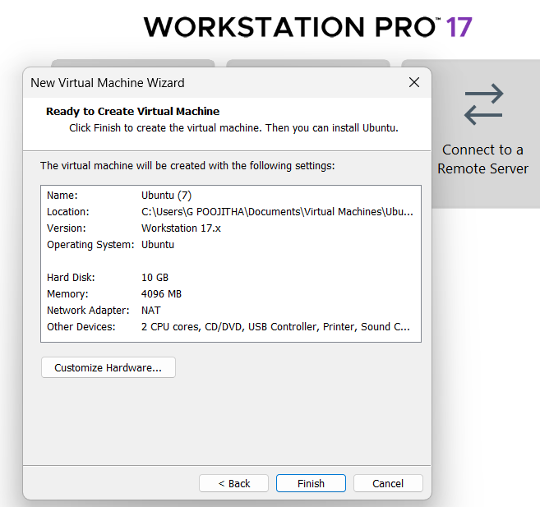 Click on Finish to Launch .
3.VM is created
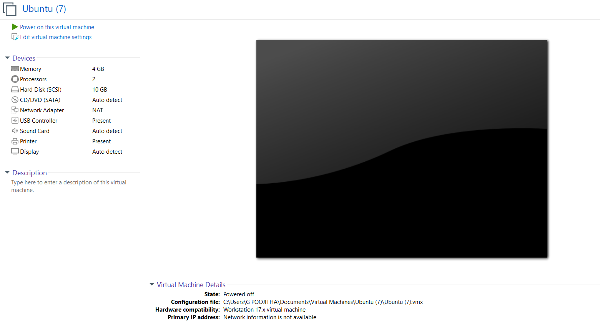
4. Create Clone
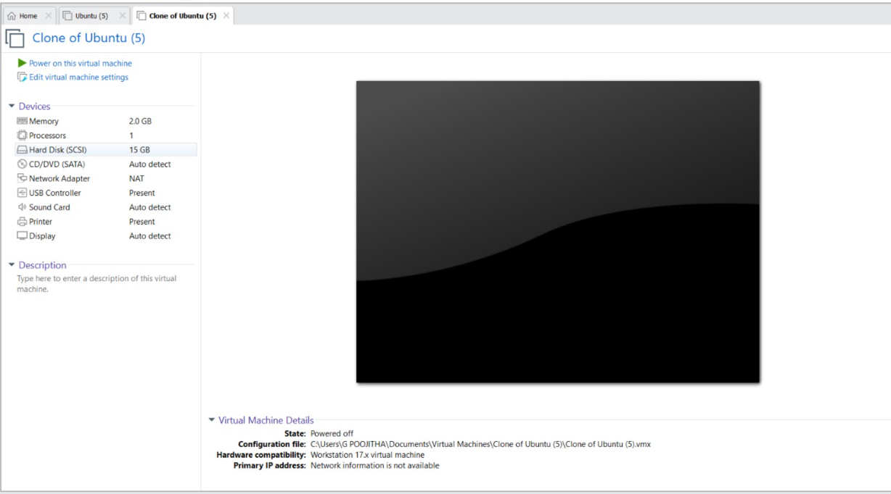
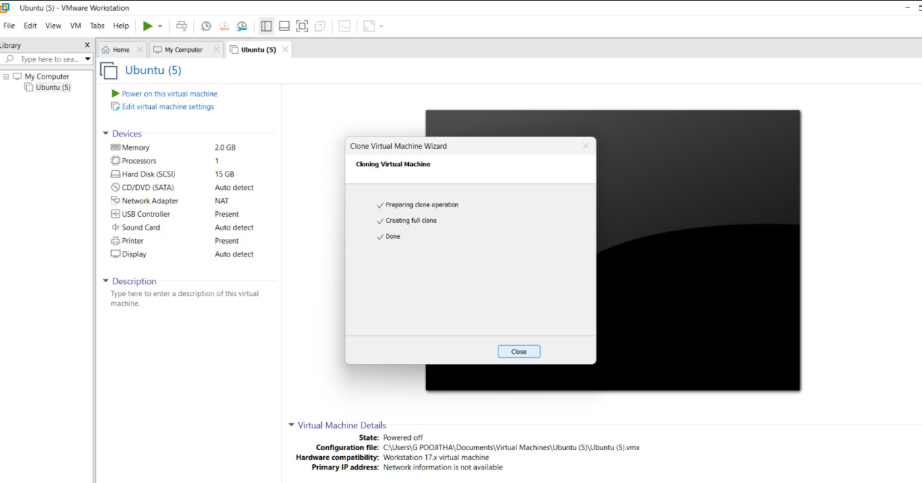
Clone has Created and it has same properties as before VM.

